**D1 Review**

**Unit 6- Software Design and Development**

In this assignment, I will be reviewing Unit 6 and I will be naming the following details about this unit:

* What I learnt
* Examples of my work
* What I found difficult
* How I overcame the difficulty

Unit 6 is about is to develop users about programming a payslip. Each of the criteria builds up to designing a payslip. In this unit, I needed to complete each criteria in order to complete the whole assignment. Each criteria was needed to be complete in order to complete D2. For D2, we needed to develop algorithms to represent a design solution. I found D2 hard out of all the criterions that I completed.

The Boss decides that nobody works more than 40 hours a week and that nobody gets paid more than £20.00 per hour. Show how you would validate data so that any values outside these limits are rejected.

The Boss thinks that the program is getting too large and unreadable, despite all of the comments that you have added. He thinks that the program structure will be improved by creating separate functions for clearly defined tasks – for example

* + Enter and validate the hours worked
  + Enter and validate the hourly rate
  + Perform the tax and NI calculations
  + Add to the overall totals
  + Assemble the data to be written to the text file.

Simplify the form of the program by adding these procedures, and then calling them from the main program.

You may have to be careful in declaring the variables locally or globally.

WHAT DID I DO TO OVERCOME THIS?

WHAT TO DO FOR D2?

The first research that I did for this part is to find out the words that I never understood and what they meant in the ‘coding world’. As found it out, I typed this in

“Private Sub TextBox1_TextChanged (sender As Object, e As EventArgs) Handles TextBox1.TextChanged

'to see if it is over 40'

If TextBox1.Text > 40 Then

MessageBox.Show(" Enter less than 40 hours")

TextBox1.Text = 0

End If

End Sub”

I needed to make the text box so that I cannot make the employee over 40hours. I did the same thing for the pay but I changed it. By now, I had completed two of them. For the other tasks, I needed to make functions for each of them and I had completed it.

All of the criterions that I have completed, I had to research on the internet, use books and other resources in order for me to complete it. Some included definitions; I looked them up on the internet.

|  |  |  |
| --- | --- | --- |
| Unit number and Name | Criteria | What did I learn? |
| *Unit 6- Software Design and Development* | ***P1*** | I learnt for this criterion that they are different types of programming. Also, they are different types of coding e.g. mark-up. It is used to create webpages. |
| ***P2*** | For this criteria, I learnt that they are different types of factors that can affect the choice of programming language e.g. availability of staff. It can put the organisation on-hold if they do not have any of the factors. For example, if one section of the business are using HTML coding, they would need specific staff that use HTML coding for it. |
| ***P3*** | P3 is all about sequence, selection and iteration. I learnt that these are the types where these are represented in aprogram. **Sequence** you cannot move on without completing the task, **selection** has a choice and **iteration** is repeated. I learnt that these three are used in programming. |
| ***P4*** | P4 is about data types. I learnt the benefits of the different types of ‘data types’. It can be used on various programmes. |
| ***P5*** | We created a system life cycle and I learnt that I needed a set of instructions to set a guide of how to make a program. I followed it up by explaining how I created it. |
| ***P6*** | In this criterion, I drew up a flowchart of the program. This part is where I had to use symbols where we revised in class as a whole and put it as a flowchart. |
| ***M1*** | M1, I had to explain and identify its importance for the program. I learnt that each of the one is important for each of them. One of them was testing. If you do not test your program, it cannot fix any problems that might occur. Therefore, I learnt that I need to maintain, test the program each time I visit it. |
| ***M2*** | M2, I had to explain the data types for my program and I had to explain the codes that I included. In this criterion, I learnt that I need to get my coding right in case I spelt or mistake something. |
| ***D1*** | In this criterion, I had to discuss the features that can improve the readability of a code. They are a number of factors that can be used to improve the readability of the code. |
| ***D2*** | D2 was the hardest out of all. I learnt that making a program is intense. We had to sort out all sorts of codes and I had to make sure that the previous coding was correct in order to move on. |

*What did I learn throughout Unit 6 for each criteria?*

**EXAMPLES OF WORK FOR UNIT 6**

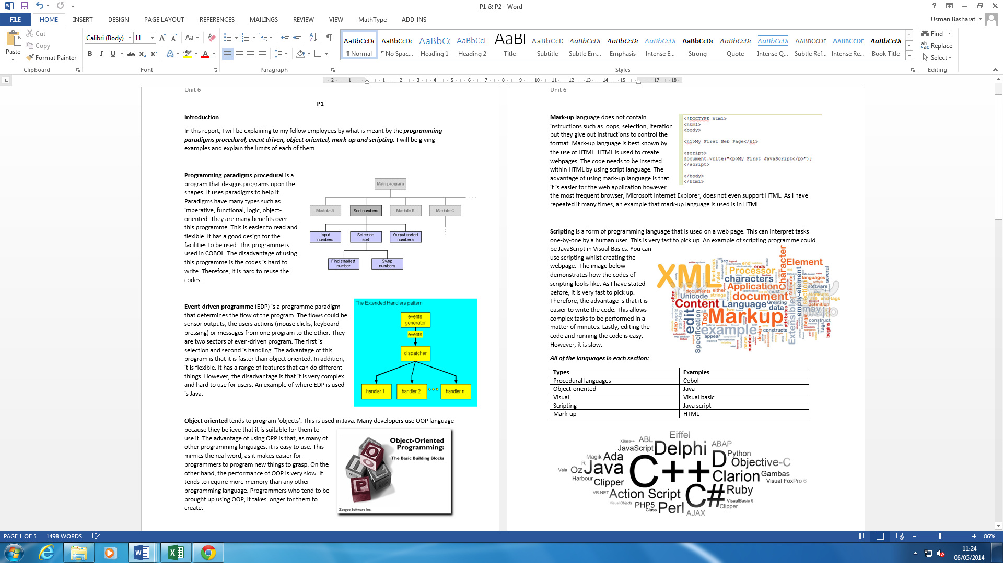

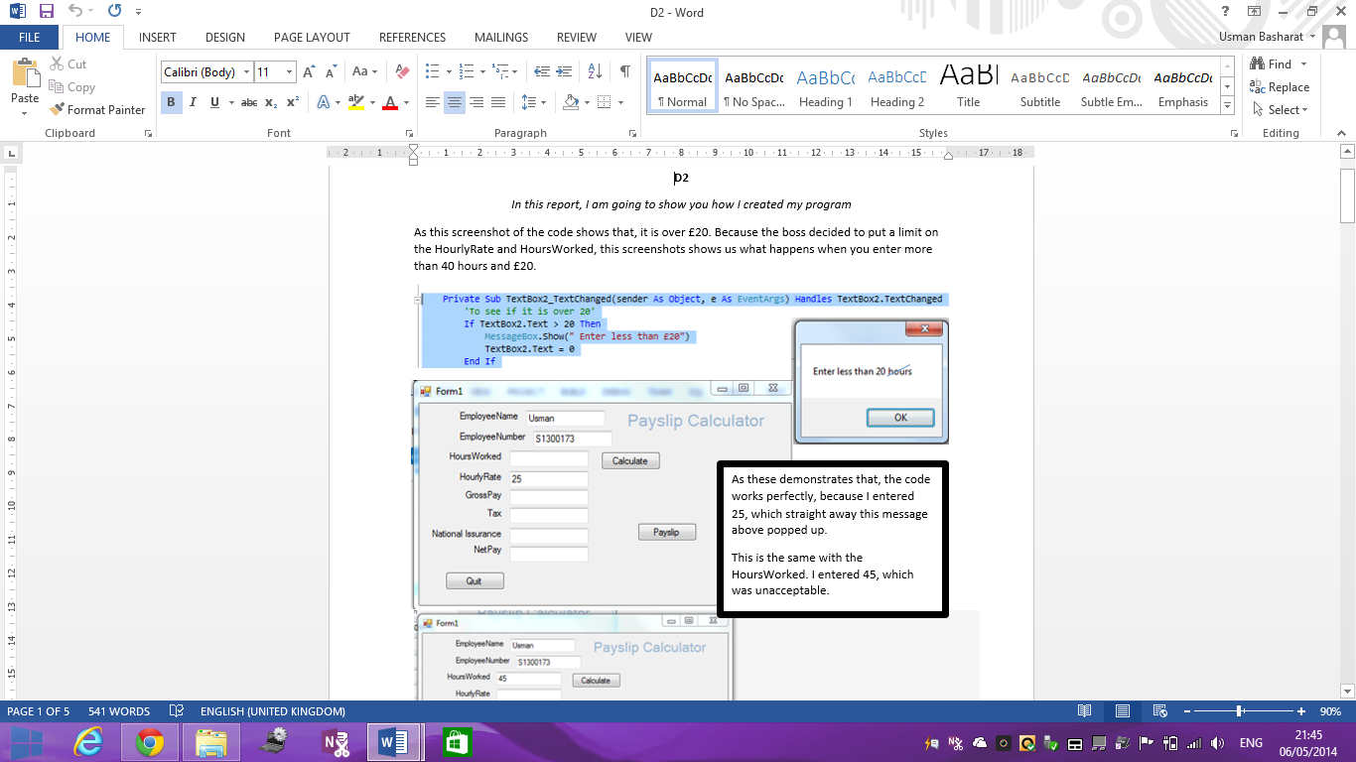

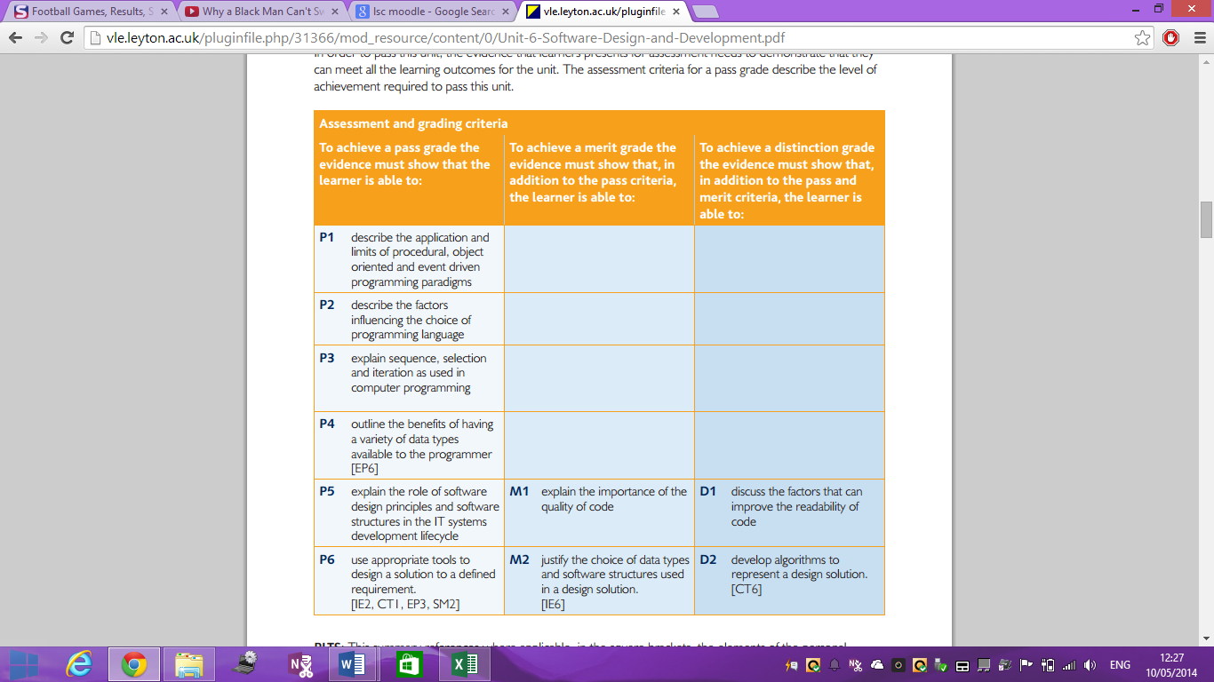

For each criteria, we need a guide for each criteria for it to be complete. Each student looks at this and understands what to do for the specific task e.g. For P3; you need to explain sequence, selection and iteration. The skills that is outlined in this section is that reading each section and understanding what to do for the task. It is important the user get it right for what to do for the task, because if he does not, he will fail the criteria.

CRITERIONS FOR UNIT 6